HM Land Registry Open Data Report

# **Introduction**

This document serves to show a brief inspection of data provided by HM Land Registry Open Data. The project initially involved cleaning the data available, including archived data for transaction, which suffered from misnamed files and csv files without header information.

Next, the defining questions were drafted. In an ideal world the defining questions would be to use the data to estimate the worth of each property in the UK, using a machine learning algorithm and some auxiliary datasets that have some information about homes that have not changed deeds in the past 25 years, as well as physical characteristics such as dimension, number of bedrooms, etc. I find this question interesting as it would be invaluable to an internet based property broker to provide an accurate estimate of what their property is worth when looking for another house to move in to.

However, to make the best use of available resources, a much simpler question was asked. How does house pricing differ between the 4 countries that make up the UK? This question was explored through analysis of how the average house price has changed across the UK over the past 50 years. Then a look at what the mean price of housing types across the UK was done as well.

Assumptions that were made when making mean calculations over time periods that the difference in the number of homes sold per month were negligible, which is quite crude and could be alleviated through using the “sales volume” column of the House Price Index (HPI) to weight the averaging.

## Issues Faced

Two main obstacles came up when processing the information. The main one was the unexpectedly large amount of time it took to reformat archived data so that it could pair up with the production data. Although I did not use this data I feel it was a good scenario for me to show an ability to clean data.

The second issue was that I was treating the HPI dataset as being a list of counties due to misunderstanding what the header information was referencing when reading its description on the website. This resulted in a quick change of direction to looking at countries in the UK so that some analysis could be shown, with the time remaining.

# Analysis

The monthly average house price in the UK shows England starting to break away from the other countries in the late ‘80s, with Northern Ireland briefly overtaking England right before the 2008 recession. At the 2008 recession all countries saw a rapid decrease in property value after a few years of rapid growth. After the recession, England has grown much faster than the other countries, with all countries seeing a sharp increase in property value during 2020, possibly due to the covid pandemic.

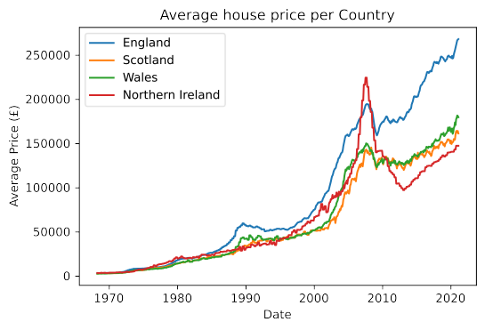Figure 1: Average house price between January 1970 and February 2021

When breaking down the different kinds of property into detached, semi-detached, terraced, and flat, it is revealed that despite all countries having detached homes as their most expensive property type, England’s non-detatched homes cost nearly as much as detached homes in Scotland and Wales, and all but terraced housing costs more than detached homes in Northern Ireland.

|  |  |  |  |  |
| --- | --- | --- | --- | --- |
| **Country** | **Detached (£)** | **Semi-Detached (£)** | **Terraced (£)** | **Flat (£)** |
| England | 379456 | 234352 | 202467 | 225878 |
| Scotland | 263394 | 159851 | 127513 | 109938 |
| Wales | 248478 | 159054 | 127623 | 115050 |
| Northern Ireland | 206817 | 134412 | 97624 | 109666 |

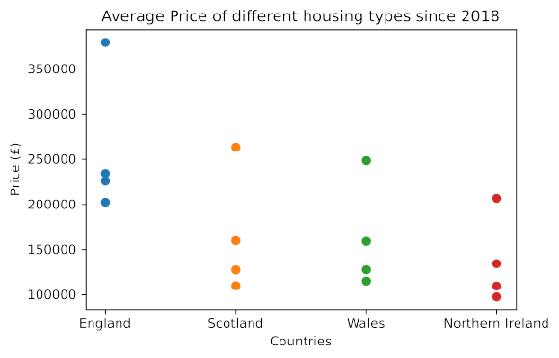Figure 2: Distribution of property types per country in the UK, exact values seen in the table above.

# Conclusion

The data shows that on average England is a much more expensive place to buy a property than the other countries in the UK. Although further research would be able to show any skew in the data such as homes near London tending to cost much more than similarly sized homes in the West of England. Along these lines, an interesting area for further research would be to investigate how property value decreases with distance from a major city, which could be achieved using the Price Paid dataset using postcode information to estimate the distance from different cities around the England and Wales.